***STATUS REPORT***

***TEAM 11***

**Work done during last week**

* The development phase is completed which includes stores, products, cart, login and signup pages.
* These developed pages are tested using selenium IDE.
* Issues mentioned in previous reports are handled by scrum master in a good way and the delayed tasks are also accomplished within the time.
* Sprint-2 is finished as per schedule, overall 67% of the project has been completed.
* As part of sprint-2, review meeting is conducted between the team today.
* Quantitative assessment of sprint-2 is provided in below burndown chart using project management tool taiga.io.

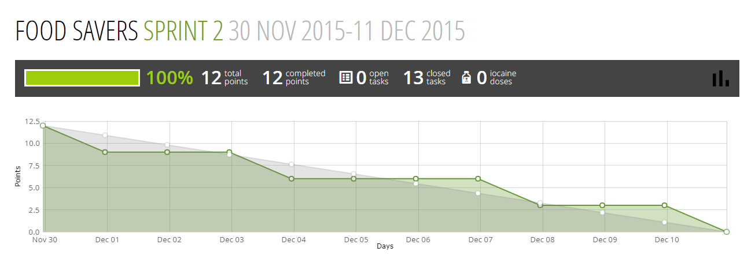**Figure 1. Burndown chart for Sprint-2**

As shown in above figure, the development of cart and login page are delayed as it took long time than expected which leads to rising in the chart (behind schedule) on dates 9th and 10th and by solving these issues the sprint is completed successfully.

***Issues***

* There was a slight deviation in the plan due to delay in the tasks which are mentioned in the previous report.
* So development phase started late by one day which is represented in the above burndown chart.
* So by using buffer time we solved the above issue.

***Participation***

As the project is in delay stage, so every member participated actively in resolving the issue.